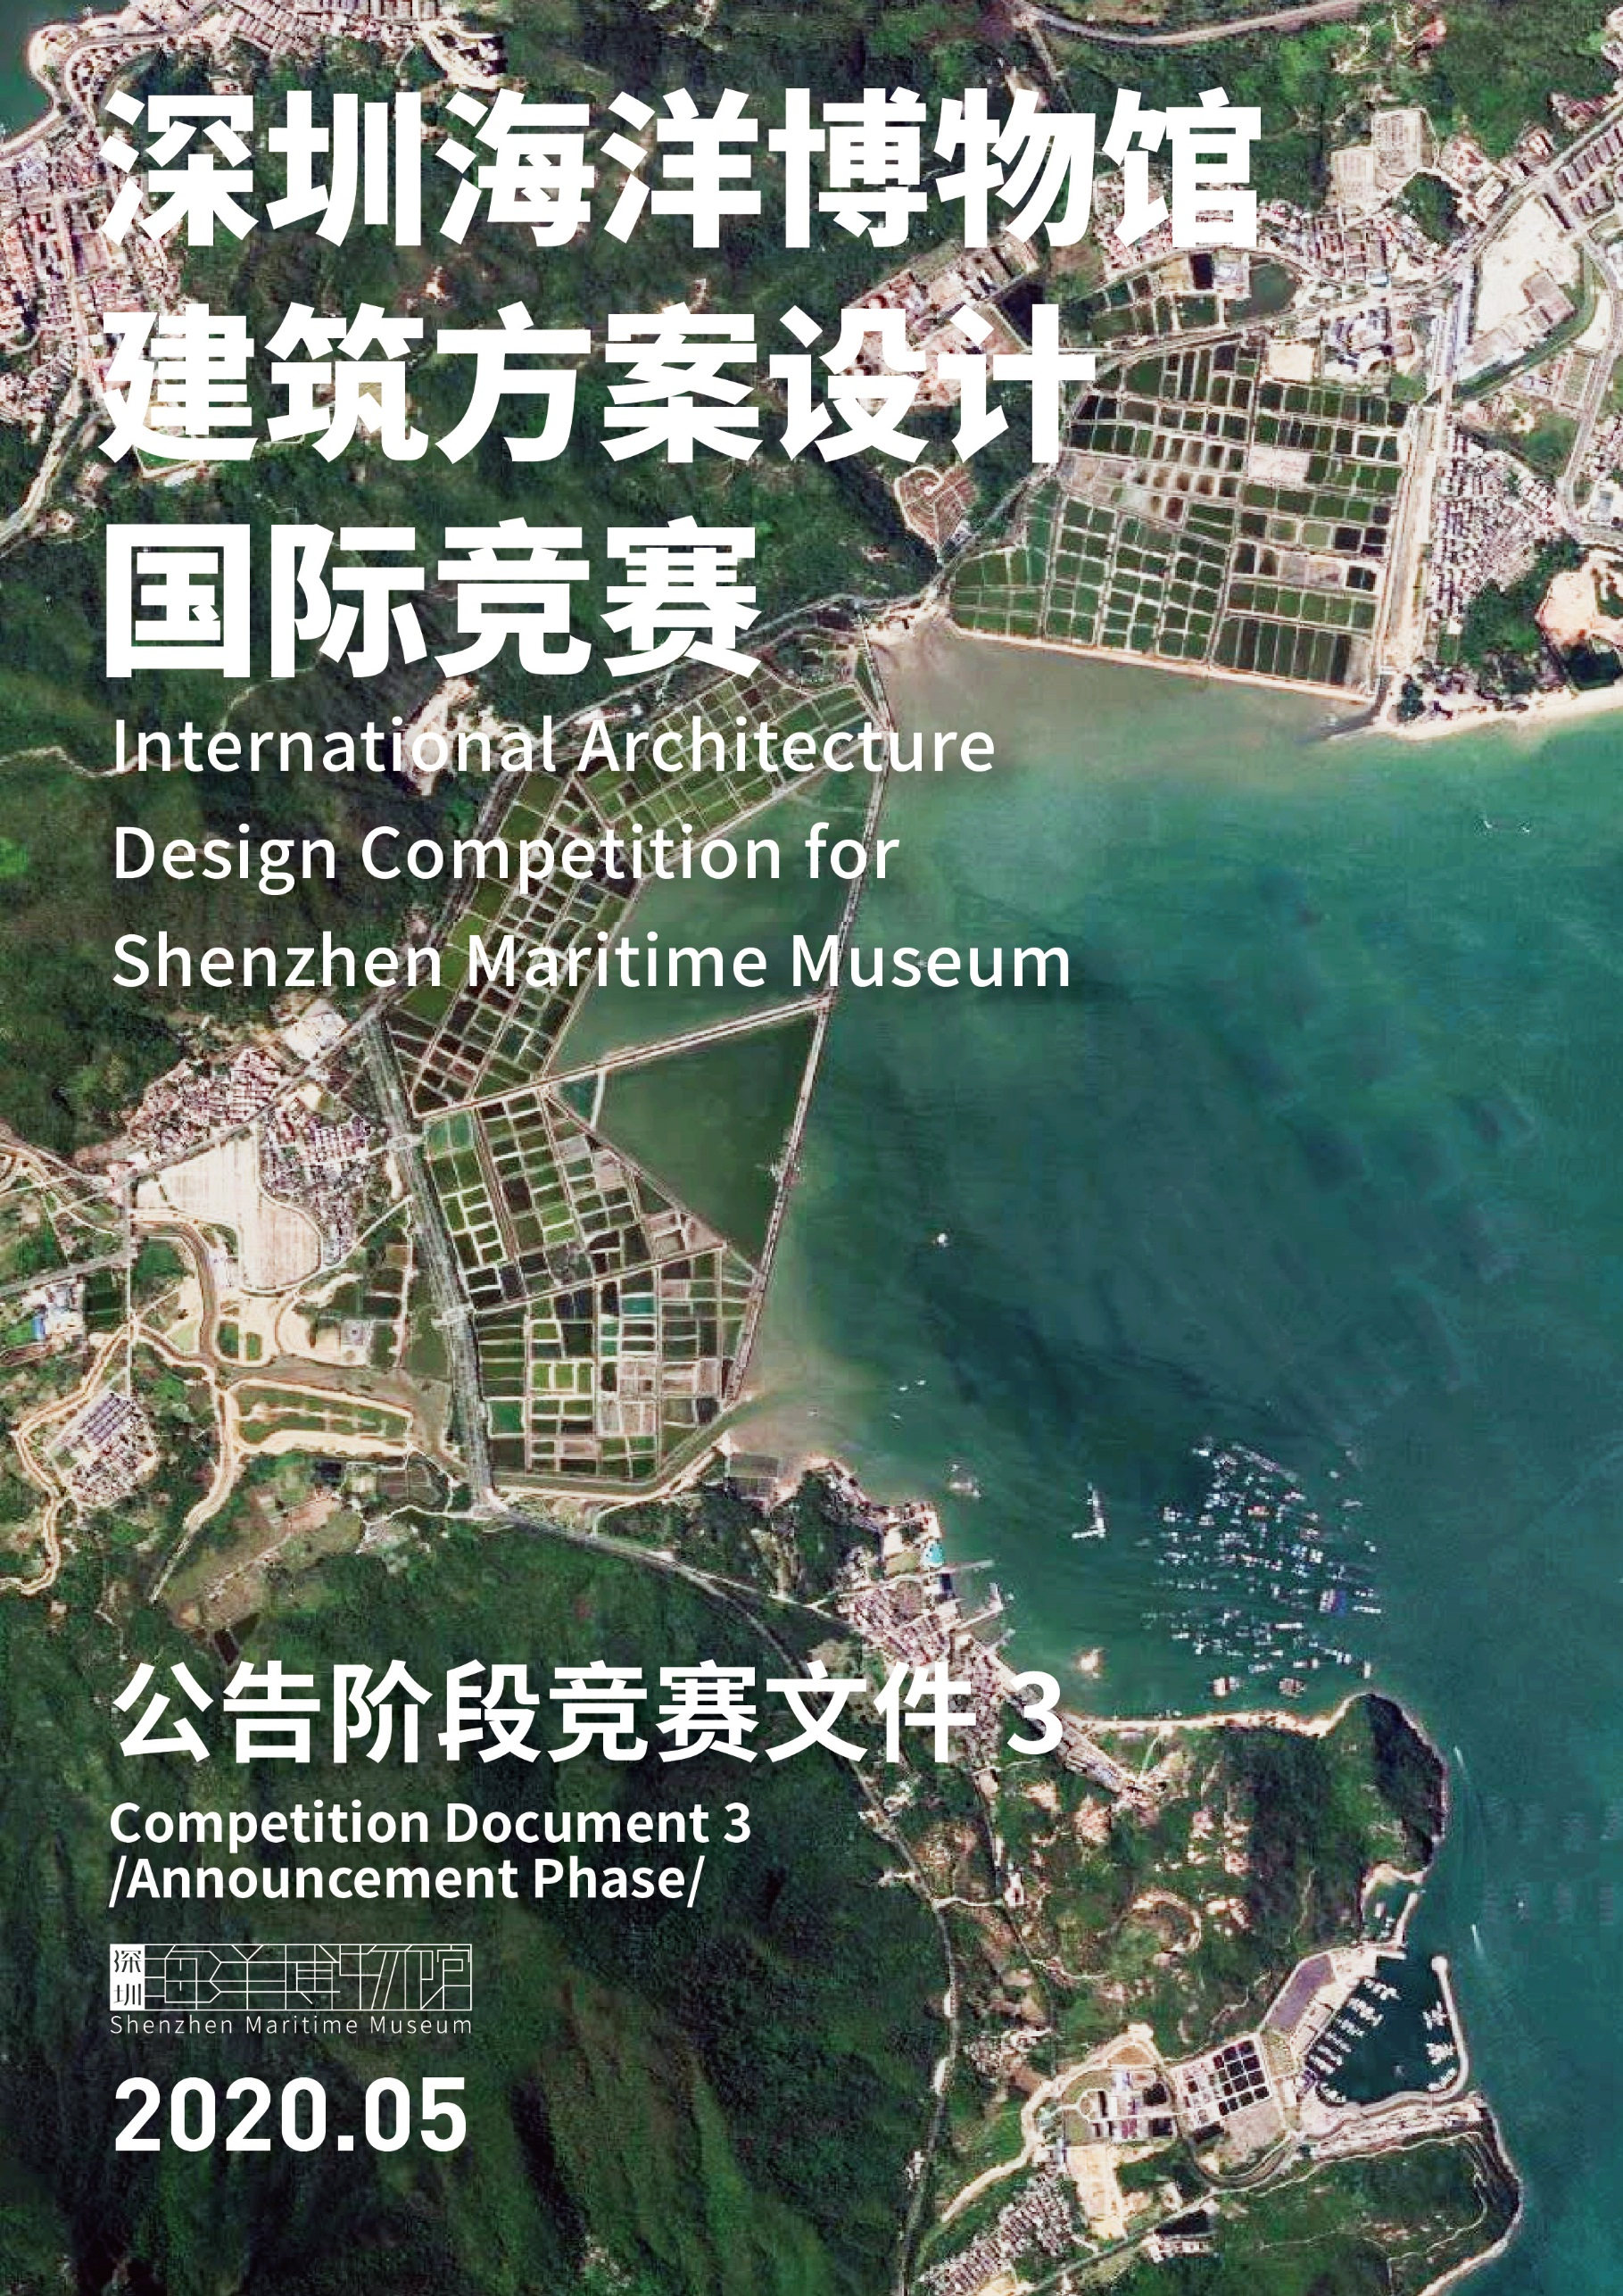

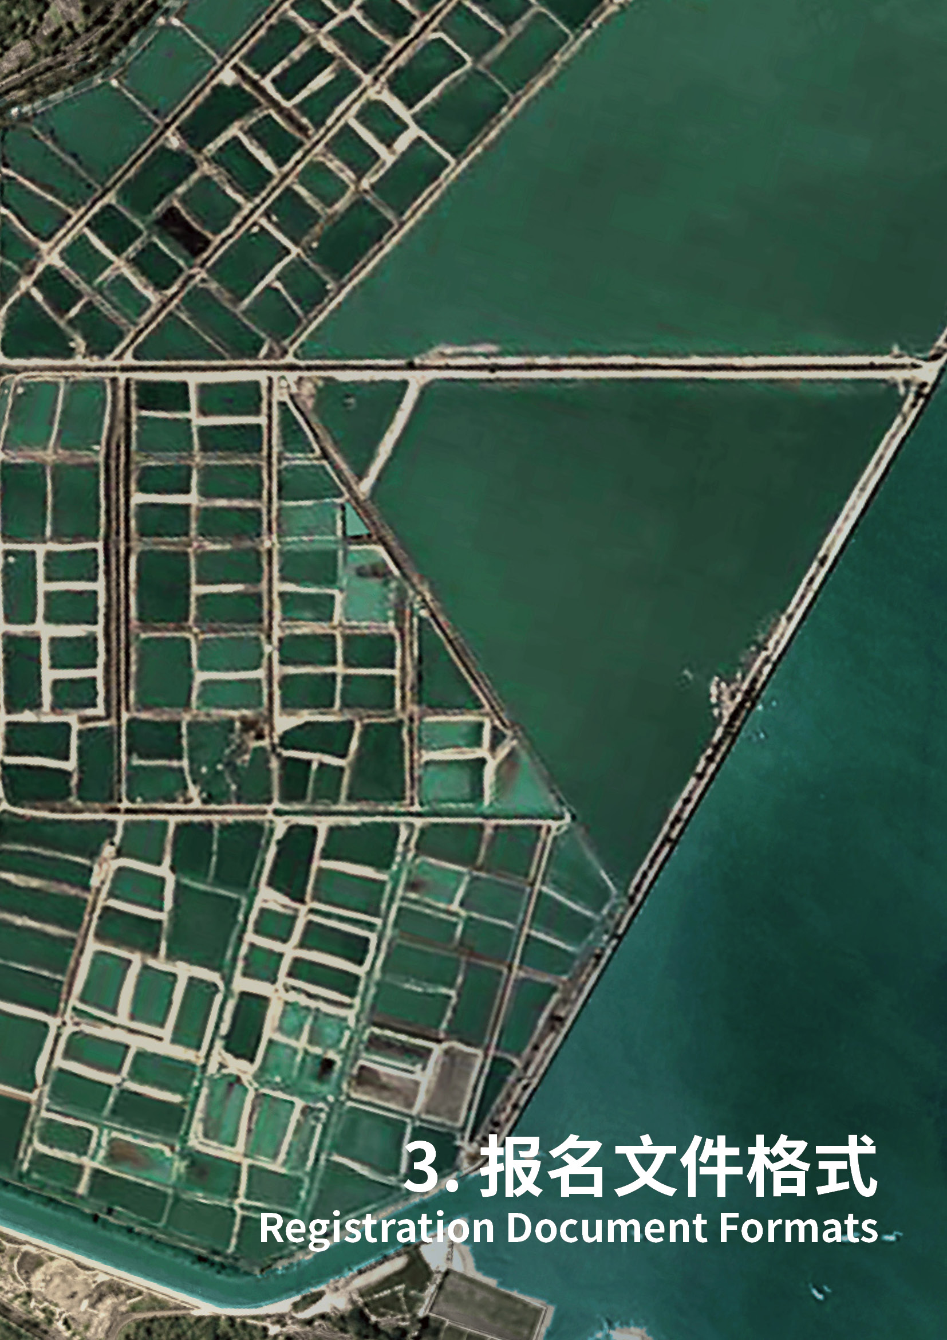

封面

Cover

深圳海洋博物馆建筑方案设计国际竞赛

International Architecture Design Competition for Shenzhen Maritime
Museum

报名文件

Registration Documents

参赛团队Participant :

（参赛团队署名应与营业执照名称一致，

如联合体参赛需标明牵头单位及联合体成员）

(The participant’s name shall be the same as specified in the business license, and any participating consortium shall indicate the leading party and other
members.)

日期Date：

目录

Contents

附件一：参赛声明
Appendix 1: Statement

附件二：参赛确认函（团队遴选后入选团队提交）
Appendix 2: Competition Participation Confirmation(To be submitted by selected design teams)

附件三：联合体协议书
Appendix 3: Consortium Agreement

附件四：报名表
Appendix 4: Registration Form

附件五：同类项目经验一览
Appendix 5: Schedule of Similar Projects

附件六：设计人员总表
Appendix 6: List of Designers

附件七：主创设计师简历及证明材料
Appendix 7:Resumes and Certificates of Chief Designers

附件一：参赛声明
Appendix 1: Statement

参赛声明
Statement
1. 本设计机构完全同意深圳海洋博物馆建筑方案设计国际竞赛的全部安排并遵 照执行。
- We fully agree with and will observe all the arrangements of the International Architecture Design Competition for Shenzhen Maritime Museum.
2. 本设计机构保证所提交资料真实、合法和有效，并承担相关的法律责任。
- We guarantee the authenticity, legality and validity of the information we submit and will assume relevant legal responsibilities thereof.
3. 本设计机构保证满足参赛须知中全部报名要求，有资格参加本项目。
- We guarantee that we meet all the registration requirements specified in the Work Rules and are qualified as a participant of the Project.
4. 本设计机构接受咨询规则中信息发布的方式，并自行承担因本单位自身原因
造成的文件缺失等对本次结果产生的任何影响。
- We accept the way of information release specified in the Work Rules, and will assume any consequence caused by our submission of incomplete documents to the selection results.
5. 本设计机构在此授权本次国际竞赛主办单位在其认为适当的时间和场合公开、
使用有关信息。
- We hereby authorize the Hosts of the Competition to disclose and use relevant information at such times and occasions as they deem appropriate.
6. 本设计机构现授权下列人员作为本次项目联系人：
- We hereby authorize the following person as our contact for the Project:
项目联系人的权限：
Authority of the project contact:
姓名：
Name：

职位：
Position：
手机：
Mobile No.：
电子邮箱：
Email address：
（以上联系方式正确有效，否则由此造成送达不成功的后果由本设计机构自负。 后续如需更换联系人，本单位将以书面形式通知。）
(The aforesaid contact information is correct and effective. We will be responsible for the consequence caused by failed delivery as result of the incorrect and non-effective information. Any change to the contact person will be informed in writing.)
公司名称（加盖公章）：
Company Name (corporate seal):
法定代表人（签字）：
Legal representative (signature):
日 期：
Date:

注：如为联合体参赛，各成员须在此处加盖公章。
Note: Each member must have its corporate seal stamped here in case of consortium.

附件二：参赛确认函（团队遴选后入选团队提交）
Appendix 2: Competition Participation Confirmation(To be submitted by selected design teams)

致：深圳市规划和自然资源局（市海洋渔业局）
深圳市建筑工务署工程设计管理中心
To: Planning and Natural Resources Bureau of Shenzhen Municipality (Municipal Ocean and Fisheries Bureau)
Engineering Design Management Center of Bureau of Public Works of Shenzhen Municipality
我方在此确认参加深圳海洋博物馆建筑方案设计国际竞赛活动，我方承诺遵守本次竞赛的一切规则，并同意和承诺如下事项：
We hereby confirm that we will participate in the International Architecture Design Competition for Shenzhen Maritime Museum. We undertake to abide by all the rules of the competition and agree and promise the following matters:
- 我方承诺按照《竞赛文件》要求按时提交设计成果。
We undertake to submit the deliverables on time in accordance with the rules of work and the requirements in the Design Brief.
- 我方承诺按照《报名文件》和《参赛确认函》所承诺的提交的主创设计人员将全程参与设计工作（附主创设计人员名单及工作分配表）。
We undertake that the chief designers as promised in the Registration Document and the Competition Participation Confirmation will fully participate in the design work (the list of the chief designers and the job list are attached).
- 我方承诺按照设计任务书要求的深度完成设计成果。
We undertake to complete the deliverables to the extent required by the Design Brief.
- 我方保证提交的设计成果内容无任何虚假、未侵犯他人知识产权。若评审过程中查出有虚假，同意作无效竞赛成果文件处理并取消参与资格。若获得设计合同之后查出有虚假，同意废除获胜资格接受处罚，承担因侵犯他人知识产权而由此引起的全部法律责任和经济责任。
We guarantee that the contents of the submitted deliverables are free from any false content and do not infringe upon the intellectual property rights of others. If our deliverables are found to be false in the review process, we agree that they will be treated as invalid and we will be disqualified. If our deliverables are found to be false after having been awarded a contract, we agree to abolish our winning qualification and accept the punishment, and bear all the legal liabilities and economic responsibilities arising from the infringement upon others' intellectual property rights.
- 如我方获得设计合同，我方将按照《参赛确认函》所承诺的设计人员组建项目设计组，完成本项目的全部设计工作。如未经主办单位书面同意更换项目设计组成员，主办单位有权取消我方的设计资格或单方面终止合同，由此给主办单位造成的损失由我方承担。
If we are awarded a design contract, we will set up a project design team constituted by the designers promised in the Competition Participation Confirmation to complete all the design work of the project. If any member of the project design team is changed without the written consent of the host, the host shall have the right to disqualify us for winning the competition or unilaterally terminate the contract, and the losses caused to the host thereby shall be borne by us.
在正式协议签署并生效之前，贵方的《竞赛文件》和《参赛确认函》将成为约束双方的合同文件的组成部分。
Prior to the execution and entry into force of the formal agreement, your Competition Document and Competition Participation Confirmation will form integral part of the contract documents binding the parties.
为方便联系，我方指派 （先生/女士）出任本次竞赛的工作联系人。联系电话： ，邮箱：
For your convenience, we have appointed (Mr. / Ms.) as the contact person for the competition: Tel: , E-mail:
特此函告！
Hereby informed!

附：
Attached:
1.主创设计人员名单及工作分配表
List of the chief designers and the job list
 | 姓名  Name | 拟承担的工作内容  Job duties to be undertaken
主创人员名单
Chief designers
设计人员名单
Designers
2.营业执照（或商业登记证明文件）扫描件（须加盖公章或法人签名）
Scanning copy of business license (or business registration certificate) (affixed with the official seal or signature of legal representative)

牵头单位
Consortium leader
单位名称（盖章或签字）：_____________________________
Name (seal or signature): _____________________________
法定代表人或授权委托人（盖章或签字）：_____________________
Legal representative or authorized representative (seal or signature):______________

联合体成员1
Consortium leader
单位名称（盖章或签字）：_____________________________
Name (seal or signature): _____________________________
法定代表人或授权委托人（盖章或签字）：_____________________
Legal representative or authorized representative (seal or signature):______________

附件三：联合体协议书
Appendix 3: Consortium Agreement

联合体协议书
Consortium Agreement
（所有成员单位名称）自愿组成联合体共同参加深圳海洋博
物馆建筑方案设计国际竞赛， （某成员单位名称）为国际竞赛的 联合体牵头单位，联合体全部成员在此承诺：
(the names of all members) hereby voluntarily form a consortium to jointly participate in the International Architecture Design Competition for Shenzhen Maritime Museum (the Competition), with (the name of a certain member) as the leading party. For this purpose, we hereby pledge that:
1. 联合体牵头单位合法代表联合体各成员负责本项目文件编制和合同谈判活
动及文件签署，并代表联合体提交和接收相关的资料、信息及指示，并处理与之 有关的一切事物，负责合同实施、组织和协调工作；联合体牵头单位指定一名代 表人执行本项目涉及的全部事宜，联合体各成员均认可联合体牵头单位代表人的 行为。
- The leading party will, on behalf of the Consortium, be responsible for the documentation and contract negotiation and signing of the Project, submit and receive relevant materials, information and instructions, and handles all matters related, including contract implementation, organization and coordination. The leading party will shall appoint a representative to implement all project-related matters, and all members of the Consortium will acknowledge the actions of the said representative.
2. 联合体授权联合体牵头单位对联合体各成员的资质等级、业务能力、工作业
绩等资料进行统一汇总后由联合体牵头单位代表人一并提交给主办方，联合体牵 头单位代表人所提交的资质等级、业务能力、工作业绩等资料代表了联合体各成 员的真实情况。
- The Consortium hereby authorizes the leading party to consolidate and submit through its representative such authentic information of the Consortium members as their qualification grade, business competence and reference projects to the Hosts.

3. 国际竞赛工作由联合体牵头单位代表人负责；联合体牵头单位代表人合法代
表联合体各成员提交并签署国际竞赛文件；联合体牵头单位代表人在国际竞赛文 件中的所有承诺均代表了联合体各成员。
- The leading party will, through its representative, direct the works related to the Competition, and submit and sign the design submissions legally on behalf of all members. All undertakings made by the said representative in the documents for the Competition represent the same of other members.
4. 确定为实施方案后，联合体成员共同与主办单位签订合同书，切实执行一切
合同文件，签署的合同协议书对联合体每一成员均具法律约束力。 4.Once the design proposal of the Consortium is finalized as the one for implementation, all members will jointly sign a contract with the Hosts, and
implement all contractual documents accordingly. The contractual agreement thus signed shall be legally binding upon all members of the Consortium.
5. 联合体中标后，联合体牵头单位代表人合法代表联合体各成员提交和接收相
关的资料、信息及指示，并处理与之有关的一切事务。
- After the Consortium wins the bid, the representative of the leading party will submit and receive the relevant data, information and instructions and handle all relevant matters legally on behalf of the Consortium.
6. 联合体成员在本项目合作中密切配合、尽职尽责，各方优质高效地完成各自
负责的工作内容。
- All members of the Consortium shall work closely with each other with due diligence and efficiently complete their respective work contents.
7. 联合体将严格按照国际竞赛文件的各项要求，递交国际竞赛文件，履行合同，
并对外承担连带责任。
- The Consortium will provide the submissions, perform the contract and assume joint and several liabilities in strict accordance with the requirements of the competition documents.
8. 联合体各成员在本国际竞赛所占有的权益份额、承担的工作内容、工作分工
及担负的责任由联合体内部自行决定。联合体全体成员对本次国际竞赛主办单位 负有单独和连带的责任。

- The members of the Consortium will decide their respective equity percentage, work contents, and division of works and responsibilities through internal consultation. All members shall be severally and jointly liable to the Hosts.
9. 联合体各成员单位内部的职责分工如下：
- Division of works and fees:
(1) 联合体牵头单位 承担 工作；

- The work scope of
(company name), the leading party of the

Consortium, includes ;
(2) 联合体成员 承担 工作；

- The work scope of
(company name), a member of the

Consortium, includes ;
(3) 联合体成员 承担 工作；

- The work scope of
(company name), a member of the

Consortium, includes ;
(4) 分工一览表
- Division of works

联合体成员单位名称一览表
List of members
在联合体中的权益份额(%)
Share of equity (%)
在联合体中拟承担的工作内
容和工作量
Work contents and workload
拟配备主要人员的名单
List of proposed designers
注：表格可根据联合体成员数量进行调整。
Notes: The table above is adjustable in view of the actual number of members in the design consortium.
10. 联合体各成员由于职责分工不明所导致工程价款和有关费用的分割以及内 部的风险、责任与主办单位无关，并不可因此向主办单位提出索赔。

- The division of the honorarium and cost split as well as the internal risks and liabilities caused by unclear division of responsibilities among the members of the Consortium are irrelevant to the Hosts. The Consortium shall not file any claim against the Hosts in this regard.
11. 本协议书自签署之日起生效，如未确定为实施方案或与主办方签署设计合同
履行完毕后自动失效。
- The Agreement shall come into force upon the date of signature. It shall become automatically invalid once the Consortium’s design proposal fails to be selected for implementation or after the Consortium has fulfilled the contract signed with the Hosts.
12. 本协议书一式 份，联合体成员和主办单位人各执一份。
- The Agreement is made in copies, with one for each of the members of the Consortium and each of the Hosts.

联合体牵头单位（盖章）：
Leading party: (corporate seal)
法定代表人或授权代表（签字）：
Legal representative or authorized representative: (signature)

联合体成员单位（盖章）：
Member: (corporate seal)
法定代表人或授权代表（签字）：
Legal representative or authorized representative: (signature)

（可增加）
(Add more members as may be necessary)

附件四：报名表
Appendix 4: Registration Form

公司注册名称
Company name for business registration
公司简介

Company profile
公司详细资料

Detailed company information
国家或地区

State or region
法定代表人

Legal representative
常驻地址

Permanent address
电话

Tel
网址

Website
电子邮箱

Email
公司成立日期

Date of incorporation
设计资格的种类/级别
Categories/grades of design qualification certificates

其他证明文件

Other documentary evidence(s)
有效的营业执照（或商业登记证明）（提供复印件，加盖公章）

Valid business license (or business registration certificate) (duly stamped photocopies)
企业资质证明文件（复印件，加盖公章，如有）

Qualification certificates of company (duly stamped photocopies, if any)
获奖文件（复印件，加盖公章，如有）

Awards (duly stamped photocopies, if any)
其他认为有必要的证明材料

Other documentary evidence(s) as may be necessary

附件五：同类项目经验一览表
Appendix 5: Schedule of Similar Projects

表1：同类项目清单
List 1: Detailed list of similar projects
将类似项目经验汇总于一张表上，放置于项目详细介绍之前，方便评审专家查阅。 For easy review of the jury members, please provide a master schedule of all similar projects before the detailed introduction of individual projects.

同类项目经验一览表
Schedule of Similar Projects
序号  No. | 完成时间  Date of Completion | 项目名称  Project Name | 项目地点  Project Location | 项目规模  Scale（㎡）

表2：同类项目简介
List 2: Brief introduction of similar projects
填写要求:
Filling requirements:

注明项目名称、规模（总建筑面积）、参与的设计内容，提供建筑方案设计合同关键页扫描件(应能体现合同名称、设计内容及规模、合同签订时间、合同签章页)及主要效果图、总图或照片，获奖项目需提供获奖证明：
It is required to specify the project name, size (GFA) and design contents, and provide scanned copy of key pages of the SD contract (which should show the contract name, design contents and size, contract signing date, signature page) and main renderings, master plan or photos. The award certificates shall be provided for the award-winning project(s).:

注：
Notes:
1、提供的业绩不超过5个，超过5个只取前5个（以联合体报名的机构提供的业绩总数不超过5个）。
1、Provide no more than 5 representative projects and only the first 5 will be considered when more than 5 representative projects are provided (design team registered in name of a consortium can provide no more than 5 representative projects).
2、上述业绩如有涉海性博物馆、水上建筑或滨水公共建筑业绩的设计团队可优先考虑。2、Prioritized consideration will be given to those with portfolio of maritime museums, overwater works or waterfront public buildings.
项目1
Project 1
项目类型Project type
项目名称 Project name
项目规模、特点
（简短说明项目国家及城市、总用地面积、建筑面积、主要功能、设计特点等）
Project scale and characteristics (describe the project country and city, total land area, floor area, major function, design features, etc.)
设计机构在该项目承担的工作范畴
Scope of work undertaken by the design agency in the project
主要设计人员的姓名、职务、作用及责任分工
Name, post, role and division of responsibilities of main designers
获奖情况
Prize winning information
建筑方案设计合同关键页扫描件
Scanning copies of key pages of design contracts
设计作品的委托方的联系人及有效办公电话
Contact person and valid office telephone number of the entrusting party of design works
相关照片或效果图（不超过5张）
Relevant photos or renderings (not more than 5)
其他证明材料（如有）
Other certificates (if any)

附件六：设计人员总表
Appendix 6: List of Designers

将设计团队人员资料汇总于一张表上，放置于各成员详细简历之前，方便评审专 家查阅。
For the easy review of the jury members, please provide a master schedule of all designers before the resumes of individual designers.

 | 姓名  Name | 单位  Company | 专业/职位 Profession/Title in this Project | 备注  Remarks
主创设计师
Chief designer
项目组成员
Member
注：可根据实际情况增减。
Note: The above table can be adjusted as may be necessary.

附件七：主创设计师简历及证明材料
Appendix 7:Resumes and Certificates of Chief Designers

主创设计师 基本情况 Basic information of chief designer
姓名Name
学历、学位及专业特长
Educational background, degree and specialty
职业资格及证明Professional qualifications and certificates
任职历史（自现职开始）
History of employment (starting from the present employment)
个人获得国内或国际行业奖项
Domestic or international industry awards received
设计经验
Experience in design
项目1
Project 1
项目类型Project type
项目名称 Project name
项目规模、特点
（简短说明项目国家及城市、总用地面积、建筑面积、主要功能、设计特点等）
Project scale and characteristics (describe the project country and city, total land area, floor area, major function, design features, etc.)
在该项目承担的工作
Work undertaken in the project
获奖情况
Prize winning information
建筑方案设计合同关键页扫描件
Scanning copies of key pages of design contracts
设计作品的委托方的联系人及有效办公电话
Contact person and valid office telephone number of the entrusting party of design works
相关照片或效果图（不超过5张）
Relevant photos or renderings (not more than 5)
其他证明材料（如有）
Other certificates (if any)

